Christian Gonzaga

CSC 424

Class Project

//Team Table

CREATE TABLE TEAMS

( TEAM_ID INTEGER(2) NOT NULL,

NAME VARCHAR(20) NOT NULL,

PRIMARY KEY(TEAM_ID));

//INSERTING DATA INTO TEAMS

INSERT INTO TEAMS

VALUES ('1','Cleveland Cavaliers');

INSERT INTO TEAMS

VALUES ('2','Golden State Warriors');

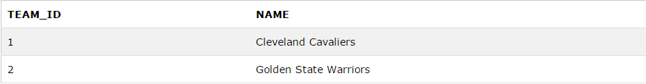

//Keeps the track of Game Scores

Game Score Table

CREATE TABLE GAMESCORES

( GAME_ID INTERGER(2) NOT NULL,

TEAM_ID INTEGER(2) NOT NULL,

SCORE INTEGER(3) NOT NULL,

RESULTS VARCHAR(30) NOT NULL,

LOCATION VARCHAR(30) NOT NULL, PRIMARY KEY(RESULTS) );

//INPUTS DATA FOR GAME SCORES

INSERT INTO GAMESCORES

VALUES ('1','1','87',’Cavs Lost Game 1’,'Oakland Colliseum');

INSERT INTO GAMESCORES

VALUES ('2','1','96', 'Cavs won game 2','Oakland Colliseum');

INSERT INTO GAMESCORES

VALUES ('3','1','87', 'Cavs lost game 3','Quickens Loan Arena');

INSERT INTO GAMESCORES

VALUES ('1','2','91', 'Warriros won game 1','Oakland Colliseum');

INSERT INTO GAMESCORES

VALUES ('2','2','95', 'Warriors lost game 2','Oakland Colliseum');

INSERT INTO GAMESCORES

VALUES ('3','2','105', 'Warriors won game 3','Quickens Loan Arena');

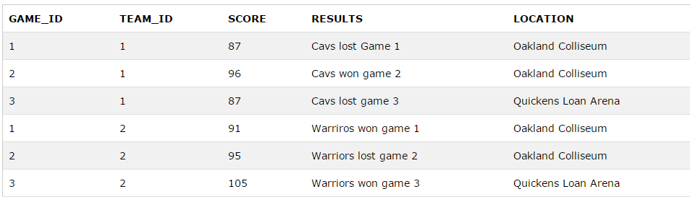

//CREATING THE TABLE FOR PLAYERS DATA

CREATE TABLE PLAYERSDATA

(

GAME_ID INTEGER(2) NOT NULL,

DATA_ID VARCHAR(3) NOT NULL,

PLAYER_ID INTEGER(2),

PLAYER_SCORE INTERGER(3) ,

PLAYER_RECOUND INTERGER(2),

PLAYER_BLOCK INEGER (2),

PLAYER_STEAL INTEGER(2),

PRIMARY KEY (DATA_ID)

);

******GOLDEN STATE WARRIORS PLAYER DATA*********

//Stephen Curry

INSERT INTO PLAYERsDATA

VALUES ('1','1f', '06','28','8','5','5');

INSERT INTO PLAYERsDATA

VALUES ('2','2f', ‘06’,'35','5','3','3');

INSERT INTO PLAYERsDATA

VALUES ('3','3f', '06','40','4','7','7');

//ANDRES IGOUDALA

INSERT INTO PLAYERsDATA

VALUES ('1','1g', '07','15','8','5','5');

INSERT INTO PLAYERsDATA

VALUES ('2','2g', '07','20','9','4','3');

INSERT INTO PLAYERsDATA

VALUES ('3','3g', '07','15','7','5','3');

//Klayton Thompson

INSERT INTO PLAYERSDATA

VALUES ('1','1h', '08','23','8','3','1');

INSERT INTO PLAYERSDATA

VALUES ('2','2h', '08','25','5','2','1');

INSERT INTO PLAYERsDATA

VALUES ('3','3h', '08','21','4','3','3');

//David Lee

INSERT INTO PLAYERSDATA

VALUES ('1','1i', '09','8','9','4','3');

INSERT INTO PLAYERSDATA

VALUES ('2','2i', '09','8','9','4','4');

INSERT INTO PLAYERSDATA

VALUES ('3','3i', '09','10','9','2','1');

//Andrew Bogut

INSERT INTO PLAYERSDATA

VALUES ('1','1j', '10','8','12','2','2');

INSERT INTO PLAYERSDATA

VALUES ('2','2j', '10','10','15','1','1');

INSERT INTO PLAYERSDATA

VALUES ('3','3j', '10','10','10','1','1');

******CLEVELAND CAVALIERS*******

//Lebron James

INSERT INTO PLAYERSDATA

VALUES ('1','1a', '01','38','10','3','4');

INSERT INTO PLAYERSDATA

VALUES ('2','2a', '01','32','8','2','3');

INSERT INTO PLAYERSDATA

VALUES ('3','3a', '01','35','12','3','5');

//Kyrie Irving

INSERT INTO PLAYERSDATA

VALUES ('1','1b', '02','15','5','5','1');

INSERT INTO PLAYERSDATA

VALUES ('2','2b', '02','17','4','3','1');

INSERT INTO PLAYERSDATA

VALUES ('3','3b', '02','18','5','3','1');

//Timofey Mosgov

INSERT INTO PLAYERSDATA

VALUES ('1','1c', '03','8','10','1','5');

INSERT INTO PLAYERSDATA

VALUES ('2','2c', '03','15','5','5','1');

INSERT INTO PLAYERSDATA

VALUES ('3','3c', '03','17','4','3','1');

//Matthew Dellavedova

INSERT INTO PLAYERSDATA

VALUES ('1','1d', '04','13','2','1','1');

INSERT INTO PLAYERsDATA

VALUES ('2','2d', '04','10','2','2','1');

INSERT INTO PLAYERsDATA

VALUES ('3','3d', '04','10','3','3','1');

//Tristana Thompson

INSERT INTO PLAYERSDATA

VALUES ('1','1e', '05','15','10','4','1');

INSERT INTO PLAYERSDATA

VALUES ('2','2e', '05','14','12','2','1');

INSERT INTO PLAYERSDATA

VALUES ('3','3e', '05','16','12','3','3');

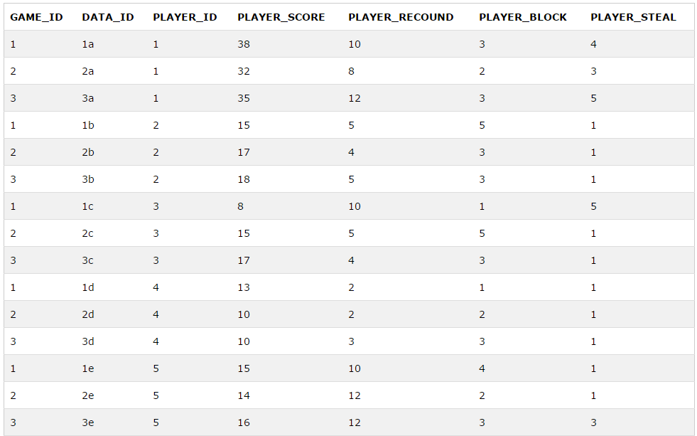

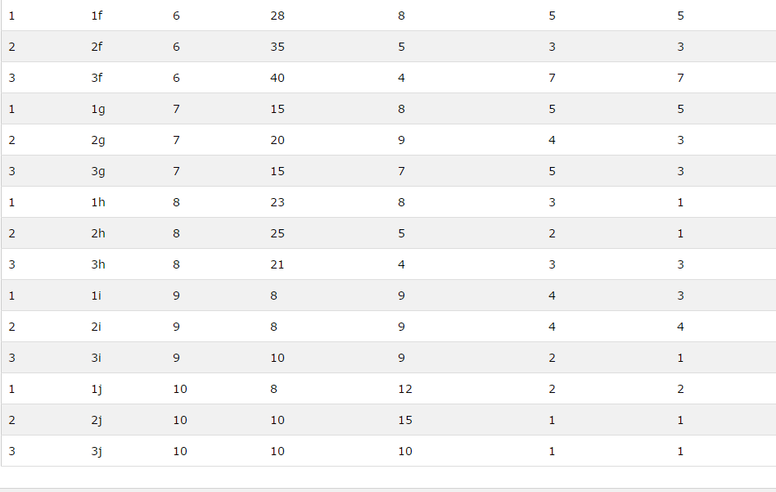

//Player Information Table

CREATE Table PLAYERSINFORMATION

(

PLAYER_ID INTEGER(2) NOT NULL,

LAST_NAME VARCHAR(20) NOT NULL,

FIRST_NAME VARCHAR(20) NOT NULL,

TEAM_ID INTEGER(2) NOT NULL,

POSITION VARCHAR(25) NOT NULL,

PRIMARY KEY (Player_ID)

);

//INSERTING PLAYER INFORMATION

INSERT INTO PLAYERSINFORMATION

VALUES ('01','JAMES','LEBRON', 'Cleveland Cavaliers', 'Small Forward');

INSERT INTO PLAYERSINFORMATION

VALUES ('02','Irving','Kyrie', 'Cleveland Cavaliers', 'Point Guard');

INSERT INTO PLAYERSINFORMATION

VALUES ('03','Mosgov','Timfoey', 'Cleveland Cavaliers', 'Center');

INSERT INTO PLAYERSINFORMATION

VALUES ('04','Dellavedova','Matthew', 'Cleveland Cavaliers', 'Shooting Guard');

INSERT INTO PLAYERSINFORMATION

VALUES ('05','Thompson','Tristana', 'Cleveland Cavaliers', 'Power Forword');

INSERT INTO PLAYERSINFORMATION

VALUES ('06','Curry','Stephen', 'Golden State Warriors', 'Point Guard');

INSERT INTO PLAYERSINFORMATION

VALUES ('07','Iguodala','Andre', 'Golden State Warriors', 'Small Forward');

INSERT INTO PLAYERSINFORMATION

VALUES ('08','Thompson','Klay', 'Golden State Warriors', 'Shooting Guard');

INSERT INTO PLAYERSINFORMATION

VALUES ('09','Lee','David', 'Golden State Warriors', 'Power Forward');

INSERT INTO PLAYERSINFORMATION

VALUES ('10','Bogut','Andrew', 'Golden State Warriors', 'Center');

QUERY QUESTION 1)

List the player’s last name and first name who scored more than 20 points on game 1. Also, include the player position.

SELECT PLAYERS.LAST_NAME, PLAYERS.FIRST_NAME, PLAYERSDATA.PLAYER_SCORE AS POINTS_FROM_GAME_1,PLAYERS.POSITION

FROM PLAYERS

LEFT JOIN PLAYERSDATA

ON PLAYERS.PLAYER_NUM=PLAYERSDATA.PLAYER_NUM

WHERE PLAYER_SCORE > 20 AND GAME_ID = 1

